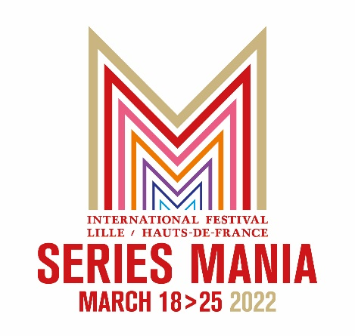

UKRAINIAN FILM PRODUCER JULIA SINKEVYCH SELECTED AS
JURY PRESIDENT FOR
SERIES MANIA’S INTERNATIONAL COMPETITION
WITH MARC DUGAIN SET TO SERVE AS VICE-PRESIDENT

LILLE & PARIS, FRANCE – March 2, 2022 – Having previously announced four jury members, Rodolphe Belmer, President of Series Mania, and Laurence Herszberg, Founder and General Director of Series Mania (March 18-25), announced today that Ukrainian film producer Julia Sinkevych has been selected as jury president for this year’s Series Mania Festival and its International Competition. In addition to being a producer, Sinkevych is co-founder of the Ukrainian Film Academy, and a member of the European Film Academy. She has always been committed to supporting Ukrainian artists and the culture of her country from Kjiv, where she lives. As her presence in Lille is not certain at this point in time, renowned French writer and director Marc Dugain, has been appointed as vice-president of this year’s jury.

“We have chosen to give the presidency of the jury of the Series Mania International Competition to a Ukrainian woman, producer and manager for several years of one of the most important film festivals in Eastern Europe: the Odesa International Film Festival (of which Series Mania has long been a partner of). By proposing this presidency to Julia Sinkevych, who carries the colors of culture in a wounded country, we wish to show our support for the people of Ukraine and attest the importance of festivals in a world in crisis, as they create a place for people to come together to exchange ideas and celebrate our diversities,” commented Belmer.
“We have always said that series are the mirror to a period of time that resonate through their stories, their characters, and their subjects. Series Mania has always been dedicated to reflecting this continuous and intimate dialogue between culture and society. This is why we feel it is essential today to turn our attention to the tragic situation that is shaking Ukraine and the entire world. We are honored to have Julia serving as our jury president,” stated Herszberg.
-more-

SERIES MANIA - JURY PRESIDENT – 2

“By bringing together, under the presidency of a Ukrainian producer, a Turkish screenwriter, a German actor, a French writer and director, an Israeli actress and a French singer, the jury of the international competition, which embodies the core of Series Mania, demonstrates that culture knows no constraints or borders,” added Herszberg.

“I am deeply moved and honored to join the jury of Series Mania which is a very special event for me. The festival celebrates the future forms of the audiovisual art, diversity of expression, while opening the minds of creators from all over the world who are closely connected to different audiences. At these times we know that culture is a powerful tool to stop the aggression and to bring to the world new talent. My country is part of that world cinema and now is fighting against all odds to demonstrate that it is the right of each human being to bring beauty, art, peace, and novelty to this world,” commented Sinkevych.

Jury members previously announced include German actor Christian Berkel (Downfall, Valkyrie), Israeli actress Shira Haas (Unorthodox), Turkish creator and director Berkun Oya (Bir Baskadir) and French singer-songwriter and model Yseult.

ABOUT JULIA SINKEVYCH
Julia Sinkevych is the film producer, co-founder and member of Supervisory Board of Ukrainian Film Academy, member of European Film Academy, member of Ukrainian Oscars committee. From 2010 until 2020, Julia worked as general producer of Odesa International Film Festival, one of the biggest audience film festivals in Eastern Europe. Besides general management of the festival organization, programming of films and curating parallel section, management of the team and organizational processes, liaisons with international partners and organizations and the promotion of the festival inside and outside of Ukraine are part of her profession. Working previously for several years for distribution and production company Arthouse Traffic, Julia was in charge of festival promotion of the selection of short films “Angry Ukrainians” and feature films produced by the company as well as for promotion of young Ukrainian filmmakers and international cooperation between film industry professionals from Ukraine and abroad. Over the years, she established a network of professional contacts in cultural and audiovisual sectors in Ukraine and abroad. Julia has also co-produced a documentary film “Close relations” by Vitaliy Mansky (2016) and “Heatsingers” (2019) by Nadia Parfan. Currently Julia is working on feature films “Lucky girl” by Marysia Nikitiuk and “Lesia” by Nana Janelidze. Julia Sinkevych graduated from the National University of Kyiv-Mohyla Academy, faculty of law and holds an MA in film production of Kyiv University of Theatre, Film and Television. She was selected to take part in SOFA program (School of film agents, Poland-Germany), completed NIPKOW program.
-more-

SERIES MANIA – JURY PRESIDENT - 3

ABOUT MARC DUGAIN
Born in Senegal, French director and novelist Marc Dugain, since 1999, has been building a career and body of work that puts forward characters confronted with great history. His first novel, La Chambre des officiers, received 20 literary awards and was adapted for the cinema by François Dupeyron in 2001. Since then, he has authored numerous novels, including La Malédiction d'Edgar (Simenon Prize in 2005) and Une exécution ordinaire (Grand Prix RTL Lire in 2007), which he himself has adapted for the cinema, and more recently Ils vont tuer Robert Kennedy (Prix Joseph Kessel in 2017). Today he directs the new collection “Espionnage” at Gallimard edition. In 2017, he directed L'Échange des princesses, based on the novel by Chantal Thomas, which earned him a nomination in the Best Foreign Film category at the César Awards. Associated with Patrick André and Charles Gillibert in the company High Sea Production, he co-produced Papicha by Mounia Meddour. He is currently developing two series with France Télévisions International.

PRESS CONTACTS:
MORRIS MARKETING – USA MIAM - FRANCE
sheila@morrispr.com rpseriesmania@gmail.com
Sheila MORRIS – 818-487-9300 Blanche Aurore DUAULT - 06 29 97 88 89
danielle@morrispr.com Nathalie iUND - 06 10 96 30 08
Danielle COTTON – 615-554-8671 Michael MORLON - 06 60 45 65 69
Claire VORGER - 06 20 10 40 56

# # #

